

**Avanti Alumni Network**

**Force for Good: 2020-21**

**Functional Document**

**JP Morgan Chase & Co.**

Table of Contents

Revisions 3

Definitions 4

Overview 5

Portals/Sites 5

Alumni (Drupal) Portal 5

Roles in Drupal 5

Site Pages 6

Admin Actions and Accesses 6

Content: 6

Structure 7

Appearance: 8

Extend 9

Configuration 9

People 11

Report 12

Contact Details in Drupal 13

Alumni Dashboard (Tabular View) 13

Google Sheets 14

Master sheet 14

Avanti Alumni Sheet 14

# Revisions

|  |  |  |
| --- | --- | --- |
| Author | Version and Date | Change(s) |
| Vedansh Agarwal | Version- 1.0.0  Date: 2021-07-20 | Initial Documentation |
| Pranaya R Behera | Version- 1.1.0  Date: 2021-08-02 | Initial Documentation |
|  |  |  |
|  |  |  |

# Definitions

|  |  |
| --- | --- |
| **Terms** | **Meaning** |
| Master Sheet | Alumni-Data Tab of Google sheet <https://docs.google.com/spreadsheets/u/1/d/17hXCfv6Q8qfrw9aMJ-ixp0OLTBgSH-4IaGCsSmMQQhY/edit#gid=1468372192> |
| LinkedIn-Master sheet/ Combined data sheet | Master-LinkedIn-Data sheet of  <https://docs.google.com/spreadsheets/d/1wyBuwamj7SQZ9kl1yAecWutC-6UI_DNl1dbZzslEEFY/edit#gid=0> |
| Charts sheet | Charts Tab of  <https://docs.google.com/spreadsheets/d/1wyBuwamj7SQZ9kl1yAecWutC-6UI_DNl1dbZzslEEFY/edit#gid=0> |
| LinkedIn data sheet | LinkedIn-Data sheet of  <https://docs.google.com/spreadsheets/d/1wyBuwamj7SQZ9kl1yAecWutC-6UI_DNl1dbZzslEEFY/edit#gid=0> |
| LinkedIn Page/  AAN LinkedIn Page | <https://www.linkedin.com/school/avanti-alumni-network/people/> |
| Portal/  AAN Portal/  Drupal Portal | Site at this address:  <http://13.126.43.196/> |
| AAN | Avanti Alumni Network |
| AAN Admins/  Avanti Admins | Users having Admin Role to AAN Portal, Read Write access to Google Sheets |

# Overview

Avanti Fellow is a non-profit organization helping students from low-income backgrounds, to have equitable access to high-quality colleges and professional growth that will create a better life and future for them. They are maintaining their student details in Google sheet.

We need to create a portal to view and manage the students and with ability to fetch students details update from their LinkedIn as well as the master Google sheet that they were using.

# Portals/Sites

* Alumni Network site(Drupal)
* Google Sheets for Admin(2 sheets)

# Alumni (Drupal) Portal

This is the site which can be accessed by all and they can visit public pages. This site has sign up and login options. Users can sign up to this sites but that has to be approved by admin. Sign up to this site is not encouraged. If a student join’s Avanti Alumni Page in LinkedIn or Admin adds student details in master Google sheet, they will be imported to this portal and upon Admin’s approval (unblock user and set up first time password for user; userId will be email id or phone number or LinkedIn URL part or firsrname_lastname etc based on availability) users will be able to login to this site.

Avanti Alumni LinkedIn page users data and Master sheet user data is source for the AAN portals student’s details. This also can be found combined in LinkedIn-Master sheet.

## Roles in Drupal

Drupal provides a set of roles which a user can belong to. Access level and privileges depend on the role a user has. Primary roles include:

* **Administrator**: Admin is the key person who handles the entire portal. Only the admin has the privilege to add, remove or modify content. He can decide what roles can have access to a particular content. An admin can even block, create or even delete a user from the portal directly.
* **Authenticated User**: A user who is registered with the portal (Avanti alumni in this scenario) will be called an authenticated user. He can access the content which is either public or limited to authenticated users (which depends on the access level set by the admin).

e.g. “Avanti Alumni” menu is not public but an authenticated user can access it.

* **Anonymous User**: A user who isn’t registered with the portal, or hasn’t logged in to the portal will be treated as an anonymous user. Mostly, he will have access to limited content (which admin has made public)

e.g. “Queries and Feedback” menu is publicly accessible.

We have installed several themes and currently theme **Zuvi 8.1.6** is in use Drupal portal which is default for all users except admin. Admin can try other suitable themes also.

Admin has a lot more access to control the site where as other has limited accesses.

## Site Pages

This site has several pages. These are following:

1. Home Page – Accessible by All
2. Login Page(/user/login) – Accessible by All
3. Avanti Alumni(/avanti-alumni) Page – Accessible by All
4. Queries and Feedback(/contact-us) – Accessible by All

## Admin Actions and Accesses

Following are most likely actions admin is expected to perform.

### Content:

Admin can go Content section and add/remove/update the contents.

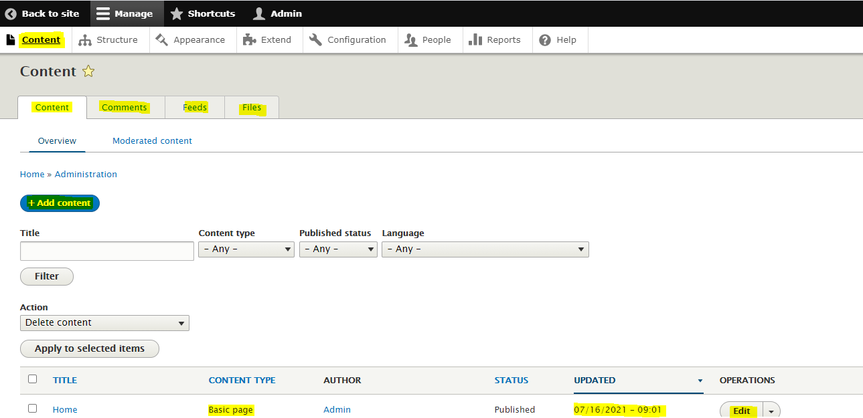

Apart from that admin also can view/manage comments, feeds and files in pages.

### Structure

Admin can view/manage, create new Structures.

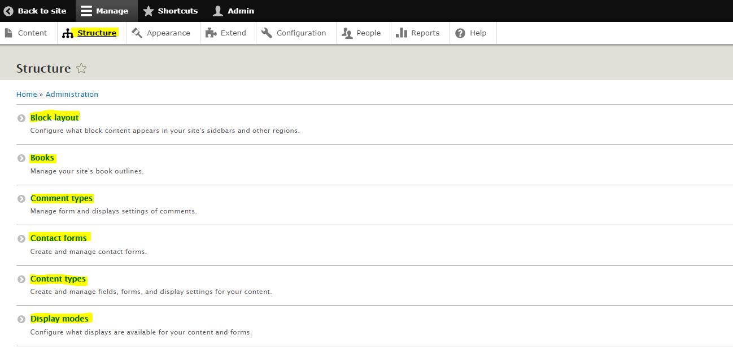

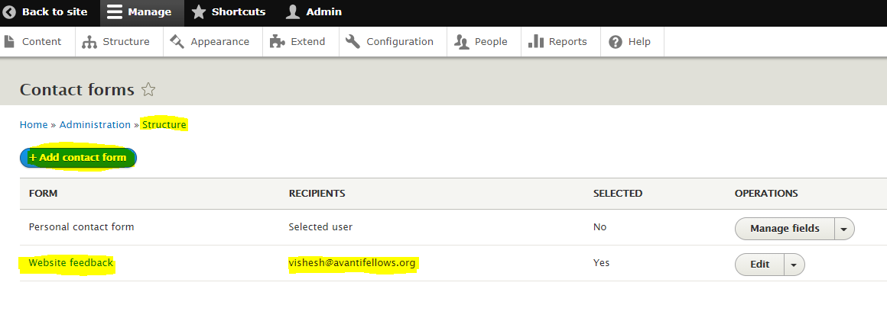

### Appearance:

This is the section where we control the sites appearance by installing and using themes.

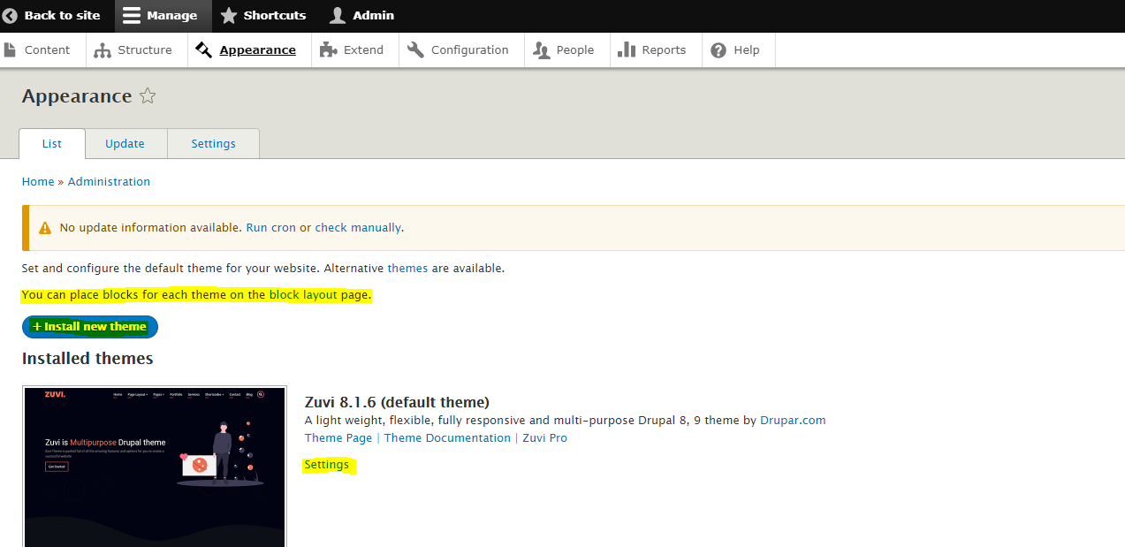

Admin can install and use new themes and change the theme’s default setting also.

**Note:** All themes are not supported with Drupal 9.1 version. Use carefully.

### Extend

This page is for downloading and to install required available plugging for different purpose and their usages.

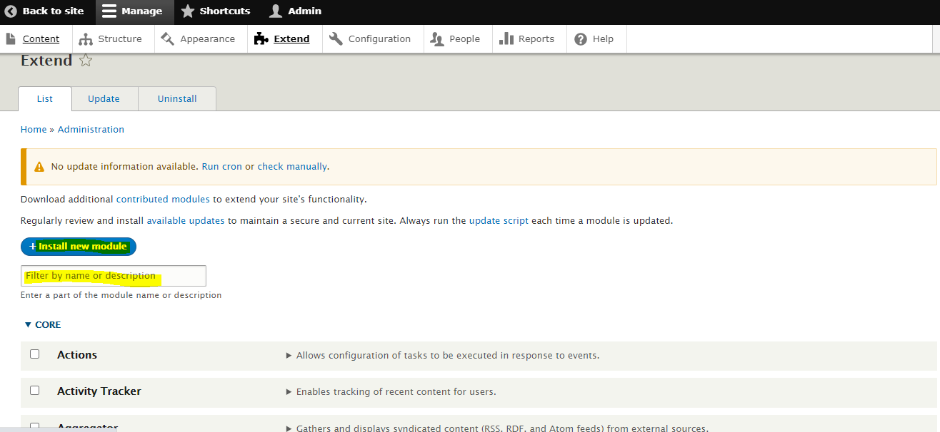

Configuration

This is one of most important and most used page.

Here admin can perform several actions like: Managing People accessing this site, Basic site settings, Content authorization, User Interface, Region and Languages, Search and indexing, URL Aliases, Performance, Error and Logging, Media management etc.

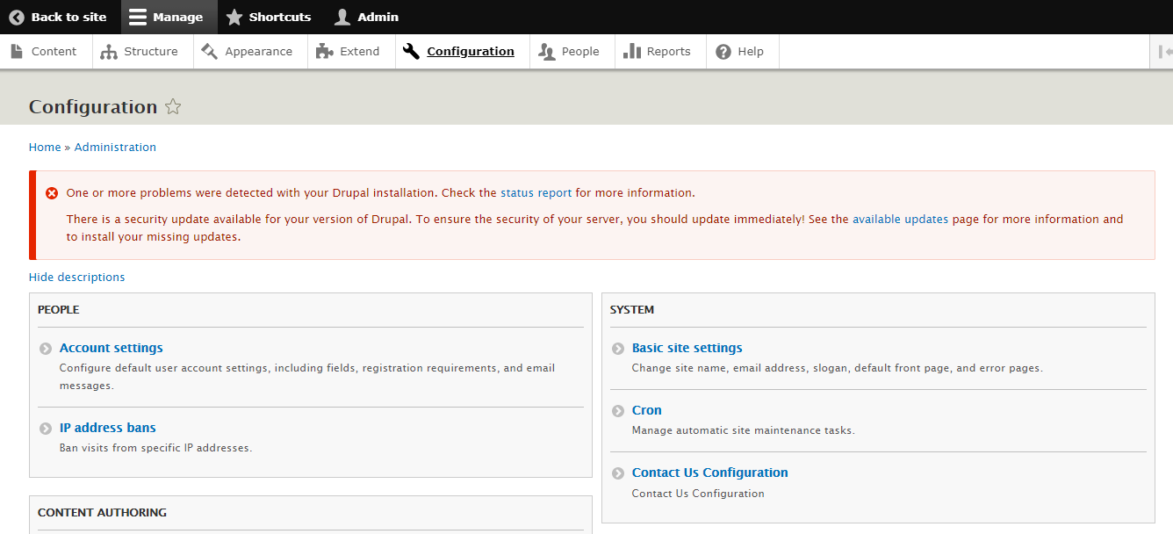

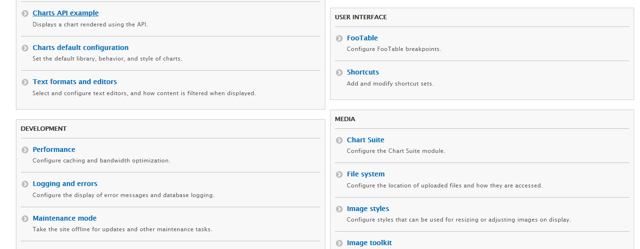

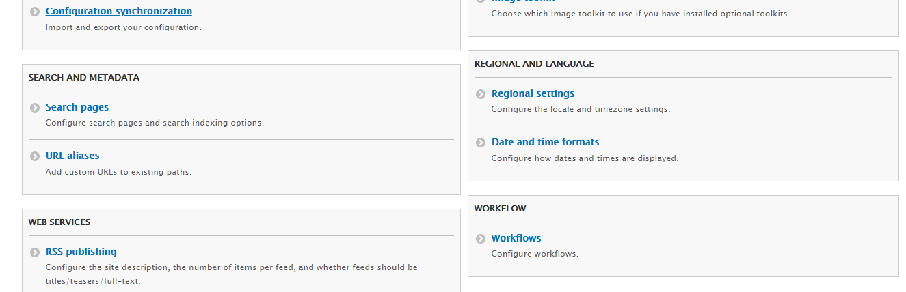

### People

This is the Page which admin used most to manage the Users, their details and roles. Admin can remove/add/search a user, update their details including password and roles. Also Admin can blacklist a user too. When a new user is imported, initially that will be blacklist user without password. Admin has to white-list the user and set a password for first time and communicate password to user by any mean in this page. Later user can reset the password.

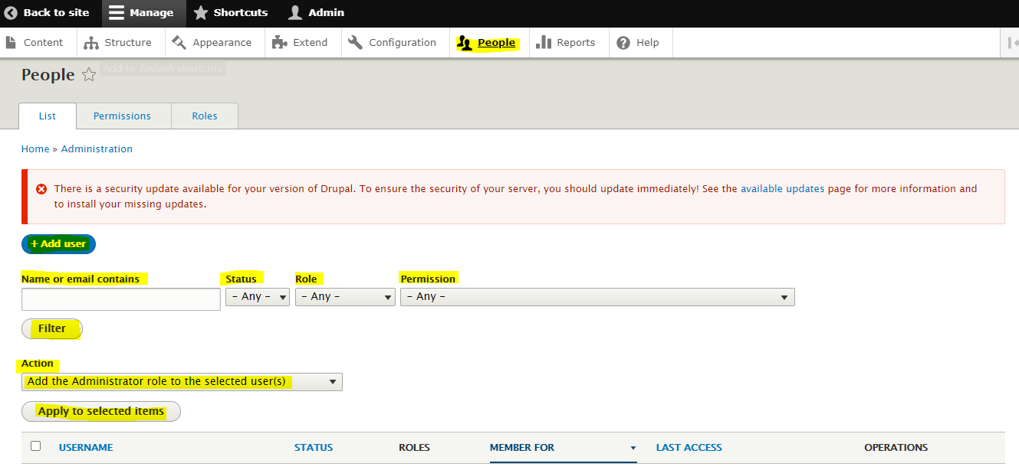

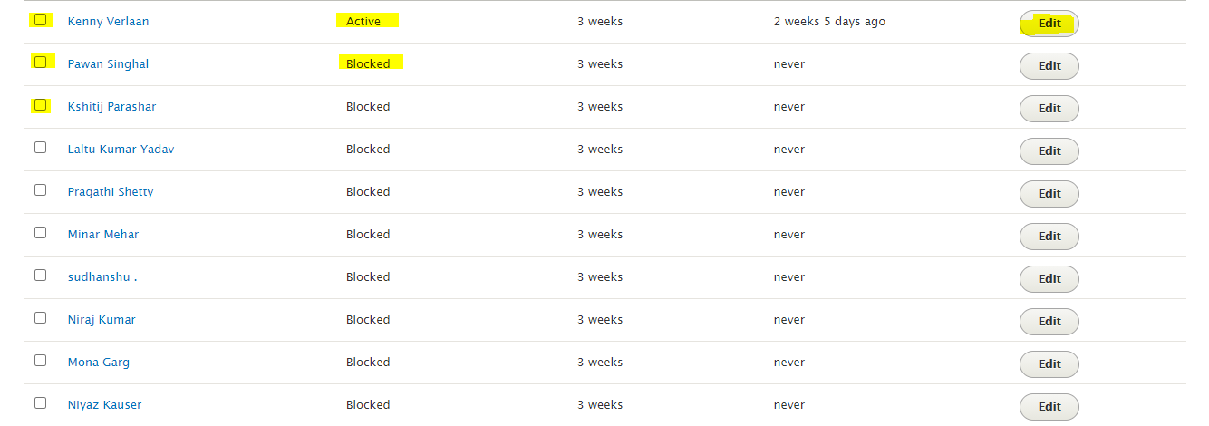

### Report

This page is for viewing site’s reports like top searches, recent logs, available updates etc.

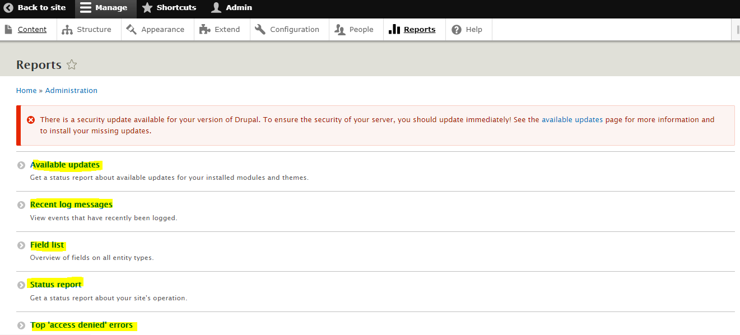

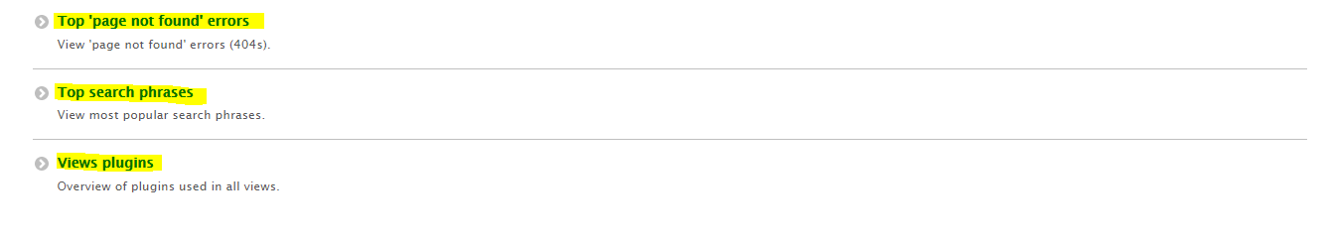

## Contact Details in Drupal

A custom block called “**contact us**” has been added to display the contact details. Currently this block is placed in the “Footer first” section of all the pages.

*Structure > Block Layout > Footer first > Contact Us*

Edit the contents of this contact block

* Login to the portal as an admin
* **Structure > Block Layout > Custom block library (tab) > Contact Us > Edit**
* Make the required changes and click **Save**

## Alumni Dashboard (Tabular View)

We have created a separate page called ***Avanti Alumni*** which contains basic information about all the users (alumni) of the portal in a single table. This dashboard is currently accessible to all the authenticated users, but if required, the access level can be changed by the admin. The table currently contains data like the name, email address, job details etc.

The key features of this dashboard are as follows:

* A user can click on the alumnus’s name in the table to view his complete profile *i.e.* his skills, job location, LinkedIn profile URL, interests etc.
* Currently, the entire grid can be sorted based on company or job designation. Furthermore, admin has rights to add other columns in the grid and control their sort-ability.

To create this table, we have used the ***DataTables*** module available for Drupal 9.

<https://www.drupal.org/project/datatables>

**Edit/Configure the dashboard**

* Log in to the portal as an admin
* **Structure > Views > Avanti Alumni > Edit**
  + To add fields, click on ***Add*** button under the *FIELDS* section
  + To change the settings, click on ***Settings*** link under the *FORMAT* section

# Google Sheets

There are two Google sheets; these are Master sheet and Avanti Alumni Sheet.

## Master sheet

Python Script has read access whereas Admin has both read and write accesses. None other have read access. This has several Tabs.

URL: <https://docs.google.com/spreadsheets/d/17hXCfv6Q8qfrw9aMJ-ixp0OLTBgSH-4IaGCsSmMQQhY/edit#gid=1468372192>

Tab data python script read: ***Alumni-Data***

Admin manually maintain this sheet for students. Python script cannot write anything here.

## Avanti Alumni Sheet

Python Script and Admin have both read and write accesses to this sheet.

This has four Tabs in use:

1. **LinkedIn-Data** Tab: This Tab contains all last web-scrapped student details from AAN Linked in page. Here content get updated once all students details web-scrapped.
2. **Master-LinkedIn-Data** Tab: This Tab contains all last web-scrapped student details from AAN Linked in page and all student details from Master sheet combined. In case of a student details present in both the sheets, then LinkedIn data take precedence assuming admin had not updated change manually but student(user) changes his/her details in linked in. Here content get updated once all students’ details web-scrapped.
3. **control-sheet** Tab: Since LinkedIn does not allow to web-scrape more(50+) profiles to web scrape, We have put a limit of maximum 40 profiles to web scrape at a time. Python script update/ read this sheet and decides to what task completed and what task to do. Admin should not update ant data in this sheet. This sheet is for intermittent usage.
4. **Charts** Tab: This Tab represents a Chart generated from ***Master-LinkedIn-Data*** tab data.

Admin can copy chart and use for their purposes.

Python Scripts reads data from control-sheet Tab only but writes in all three Tab. Charts Tab chart get updated automatically on a refresh upon *Master-LinkedIn-Data*tab data update.

URL: <https://docs.google.com/spreadsheets/d/1wyBuwamj7SQZ9kl1yAecWutC-6UI_DNl1dbZzslEEFY/edit#gid=618314590>